UFCF9Y-60-M - CSCT Masters project

As part of my master’s dissertation on developing an AI-powered fair shift scheduling system for our restaurant, your feedback is crucial. This interview aims to gather insights into how our current scheduling work.

1. Do you use forecast data for shift scheduling?
   1. **Follow-up**: If yes, how do you estimate the workload for upcoming shifts? Are there specific indicators or trends that you look for?
2. How do you adjust the staffing needs according to the workload predictions for each shift?
3. When scheduling, do you consider the working skills of each employee?
   1. **Follow-up**: How do you balance the team to ensure there is a mix of skills on each shift? Could you give an example of how you've strategically placed certain staff members together?
4. Do you differentiate staffing needs based on different sales brackets as shown in the sales distribution chart?

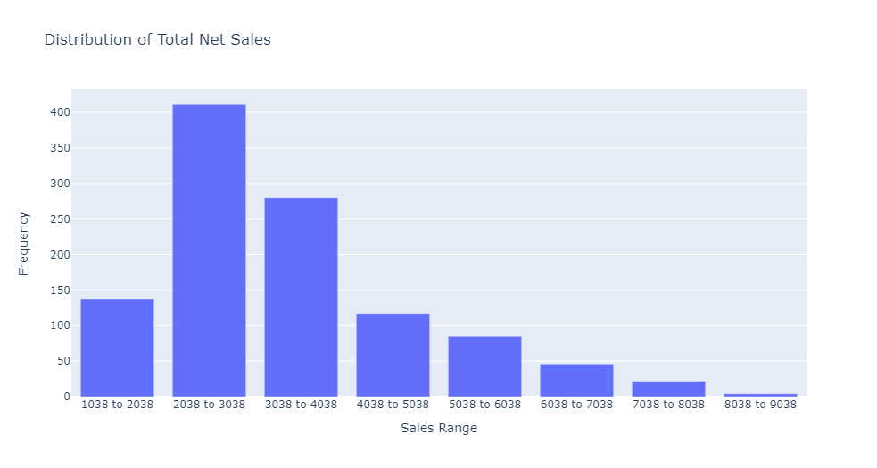

1. How do you ensure that all necessary roles are covered during shifts, particularly during peak predicted sales periods?